CO-3 [AT2]
Name: K. Sree Lakshmi
Reg No: 192512149

7. Design a low-latency communication architecture for edge-assisted smart city services.
Code:
clc;
clear;
close all;

% Number of Smart City Devices
devices = 10;

% Device IDs
device_id = 1:devices;

% Random Processing Delay (ms)
processing_delay = randi([2 6],1,devices);

% Communication Delay
cloud_comm_delay = 40 + randi([5 15],1,devices);
edge_comm_delay = 8 + randi([2 5],1,devices);

% Total Latency
cloud_latency = processing_delay + cloud_comm_delay;
edge_latency = processing_delay + edge_comm_delay;

% Display Results
disp('Device Cloud Latency(ms) Edge Latency(ms)');
disp([device_id' cloud_latency' edge_latency']);

% Plot Comparison
figure;

bar(device_id,[cloud_latency' edge_latency'],'grouped');

xlabel('Smart City Devices');
ylabel('Latency (ms)');
title('Cloud vs Edge Computing Latency');

legend('Cloud','Edge');
grid on;

% Average Latency
avg_cloud = mean(cloud_latency);
avg_edge = mean(edge_latency);

fprintf('\nAverage Cloud Latency = %.2f ms\n',avg_cloud);
fprintf('Average Edge Latency = %.2f ms\n',avg_edge);

% Pie Chart
figure;

pie([avg_cloud avg_edge],{'Cloud','Edge'});
title('Average Communication Latency');

Output:
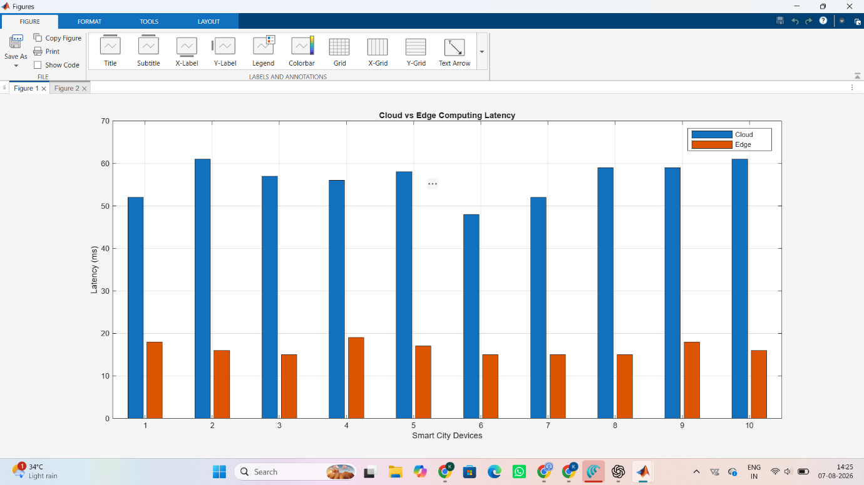

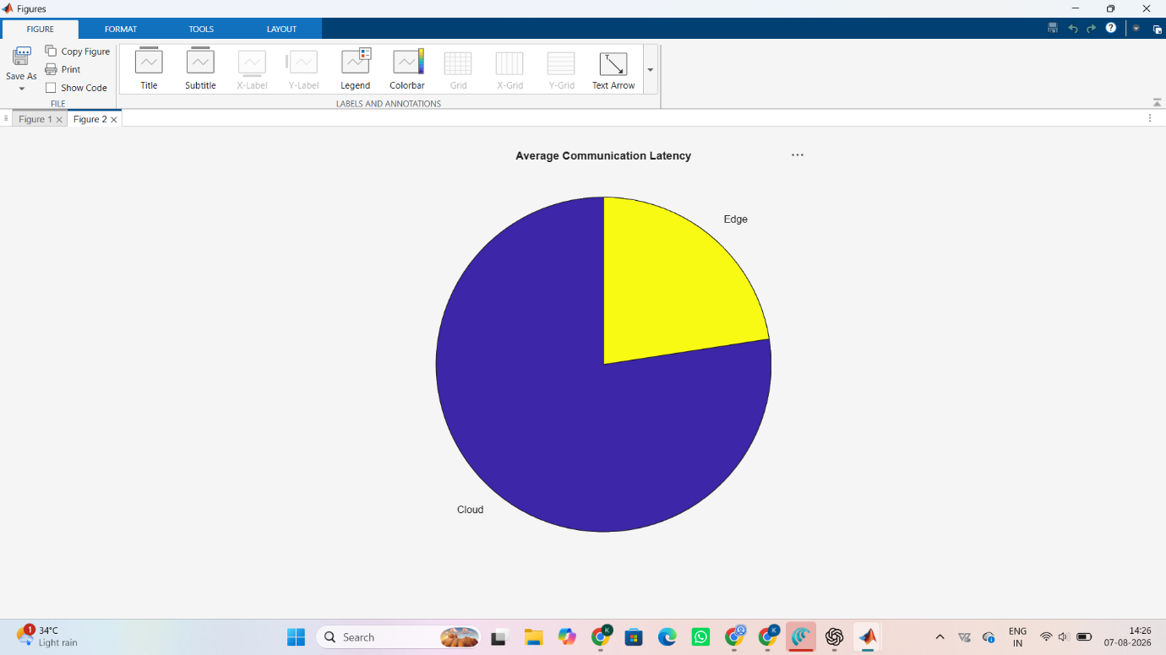

14. Develop a network management architecture for cloud-assisted wireless systems.

Code:
clc;
clear;
close all;

% Number of wireless nodes
numNodes = 10;

% Generate random network traffic (Mbps)
traffic = randi([10 100],1,numNodes);

% Generate random latency (ms)
latency = randi([5 50],1,numNodes);

% Cloud server capacity (Mbps)
cloudCapacity = 600;

% Total network traffic
totalTraffic = sum(traffic);

% Calculate cloud utilization
utilization = (totalTraffic/cloudCapacity)*100;

% Display node information
disp('--------------------------------------------');
disp(' Cloud-Assisted Wireless Network Management ');
disp('--------------------------------------------');

for i = 1:numNodes
fprintf('Node %d --> Traffic = %d Mbps, Latency = %d ms\n', ...
i, traffic(i), latency(i));
end

fprintf('\nTotal Network Traffic = %d Mbps\n', totalTraffic);
fprintf('Cloud Utilization = %.2f %%\n', utilization);

% Network Status
if utilization < 50
status = 'Low Load';
elseif utilization < 80
status = 'Normal Load';
else
status = 'High Load';
end

fprintf('Network Status = %s\n', status);

%-----------------------------
% Plot 1: Traffic per Node
%-----------------------------
figure;
bar(traffic);
grid on;
xlabel('Wireless Nodes');
ylabel('Traffic (Mbps)');
title('Traffic Distribution Across Wireless Nodes');

%-----------------------------
% Plot 2: Latency
%-----------------------------
figure;
plot(1:numNodes, latency,'-o','LineWidth',2);
grid on;
xlabel('Wireless Nodes');
ylabel('Latency (ms)');
title('Latency of Wireless Nodes');

%-----------------------------
% Plot 3: Cloud Utilization
%-----------------------------
figure;
bar(utilization);
ylim([0 120]);
grid on;
ylabel('Utilization (%)');
title('Cloud Resource Utilization');

if utilization > 80
text(1, utilization+3,'High Load','HorizontalAlignment','center');
else
text(1, utilization+3,'Normal','HorizontalAlignment','center');
end

Output:
